

**Scotch College**

**Semester One Practice Examination, 2016**

**Question/Answer Booklet**

**Year 12 MATHEMATICS METHODS**

**Section Two:**

**Calculator-assumed**

**J. Fletcher**

**P. Newman**

____ **S. Reyhani**

**Teacher:**

**Name:**

**Time allowed for this section**

Reading time before commencing work: 10 minutes

Working time for this section: 100 minutes

**Material required/recommended for this section**

***To be provided by the supervisor***

This Question/Answer Booklet

Formula Sheet (retained from Section One)

***To be provided by the candidate***

Standard items: pens, pencils, pencil sharpener, eraser, correction fluid, ruler, highlighters

Special items: drawing instruments, templates, notes on two unfolded sheets of A4 paper, and up to three calculators satisfying the conditions set by the Curriculum Council for this examination

**Important note to candidates**

No other items may be taken into the examination room. It is **your** responsibility to ensure that you do not have any unauthorised notes or other items of a non-personal nature in the examination room. If you have any unauthorised material with you, hand it to the supervisor **before** reading any further

**Structure of this paper**

|  |  |  |  |  |
| --- | --- | --- | --- | --- |
| Section | Number of questions available | Number of questions to be answered | Working time (minutes) | Marks  available |
| Section One:  Calculator-free | 7 | 7 | 50 | 50 |
| Section Two  Calculator-assumed | 14 | 14 | 100 | 100 |
|  |  |  |  | 150 |

**Instructions to candidates**

1. The rules for the conduct of Western Australian external examinations are detailed in the *Year 12 Information Handbook 2010*. Sitting this examination implies that you agree to abide by these rules.

2. Write your answers in the spaces provided in this Question/Answer Booklet. Spare pages are included at the end of this booklet. They can be used for planning your responses and/or as additional space if required to continue an answer.

* + Planning: If you use the spare pages for planning, indicate this clearly at the top of the page.
  + Continuing an answer: If you need to use the space to continue an answer, indicate in the original answer space where the answer is continued, i.e. give the page number. Fill in the number of the question(s) that you are continuing to answer at the top of the page.

3. **Show all your working clearly.** Your working should be in sufficient detail to allow your answers to be checked readily and for marks to be awarded for reasoning. Incorrect answers given without supporting reasoning cannot be allocated any marks. For any question or part question worth more than two marks, valid working or justification is required to receive full marks. If you repeat an answer to any question, ensure that you cancel the answer you do not wish to have marked.

4. It is recommended that you **do not use pencil** except in diagrams.

Question 8. [7 marks]

A particle moves along a straight line such that its displacement, *y* metres at time *t* seconds is given by . Determine:

1. An expression for the velocity of the particle at time *t*.
2. The maximum velocity of the particle.
3. An expression for the acceleration of the particle at time *t*.
4. The velocity of the particle when .

Question 9. [4 marks]

a) Determine the area enclosed by the graphs of the two parabolas $f\left(x\right)={-x}^{2}+5x+1$ and $g\left(x\right)=3x^{2}-15x+17$ [2]

b) Circle the integration statements that would give the **correct** answer to the area of the shaded region below. [2]



$\left|\int_{0}^{5}{f(x)dx}\right|$ $-\int_{0}^{4}{f(x)}dx+\int_{4}^{5}{f(x)}dx$

$\int_{0}^{5}{\left|f(x)\right|}dx$ $\int_{4}^{0}{f(x)}dx+\int_{4}^{5}{f(x)}dx$

Question 10. [7 marks]

Using **calculus techniques**

1. Find the exact area enclosed by the x-axis and the graph of  between  . [5]
2. Evaluate *p* if  and *p* > 1.

Question 11. [7 marks]

1. On the axes below are the sketches of the functions  ,  and . [3]

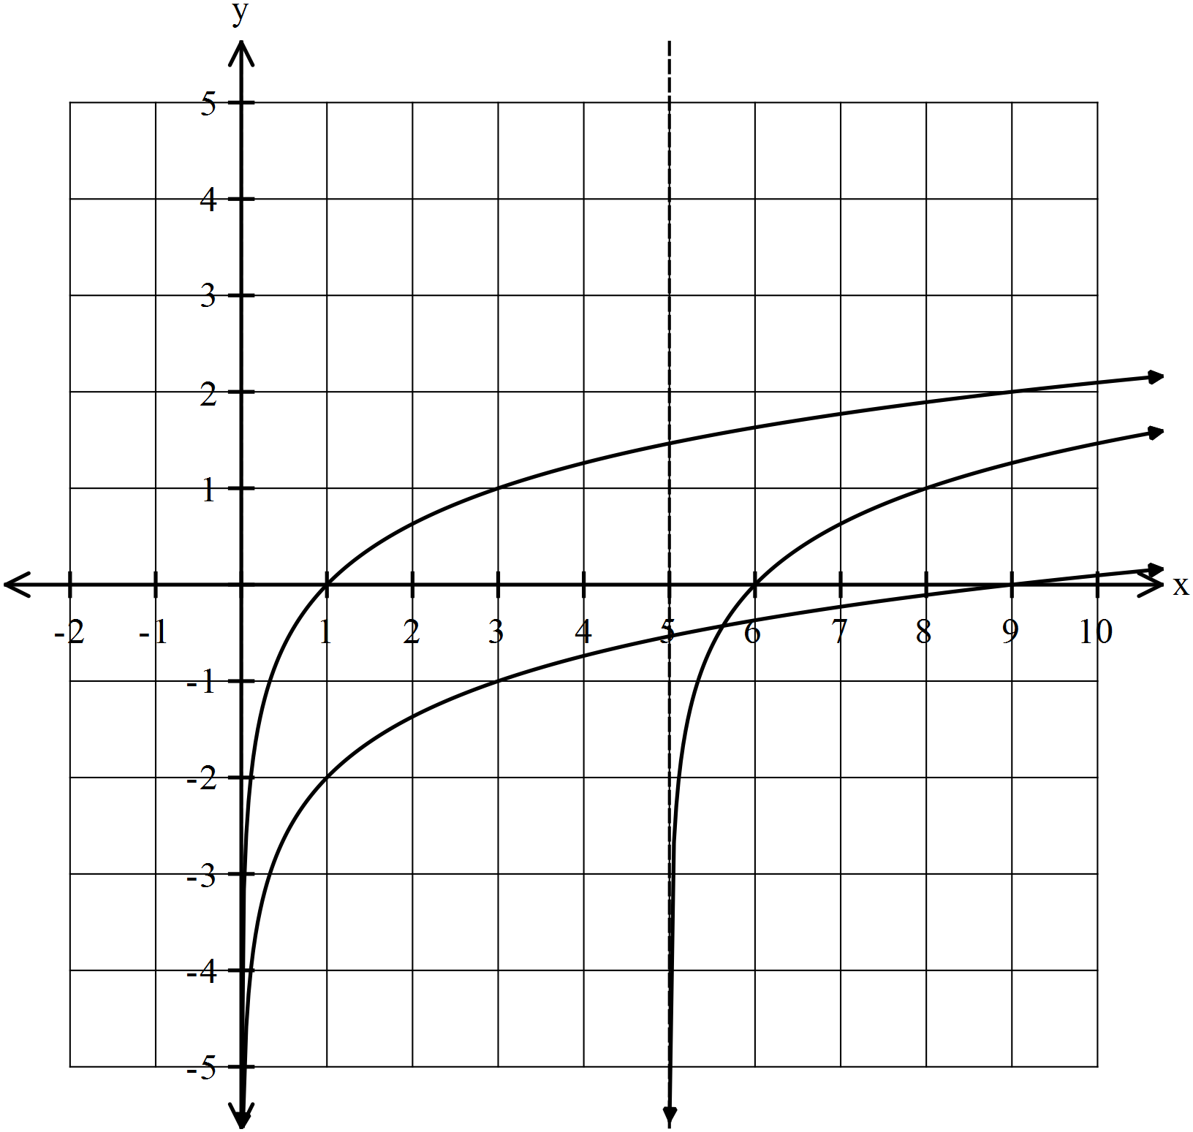

1. Determine the value of *a*, *b* and *c*.
2. The formula  calculates the pH level where  is the hydrogen ion concentration in moles/L.
3. Calculate the hydrogen ion concentration if the pH is 6.89. [2]
4. Calculate the pH if the hydrogen concentration in  . [2]

Question 12. [4 marks]

Use your knowledge of antidifferentiation to determine $f(x)$ given that $f\left(3\right)=72$, $f^{'}\left(-2\right)=-20$ and $f^{''}\left(x\right)=-12x$

Question 13. [3 marks]

Evaluate 

Question 14. [12 marks]

1. Consider the functions . Using calculus techniques, determine the area bound by the function and the x-axis for .
2. Sketch the first and second derivative of the following.

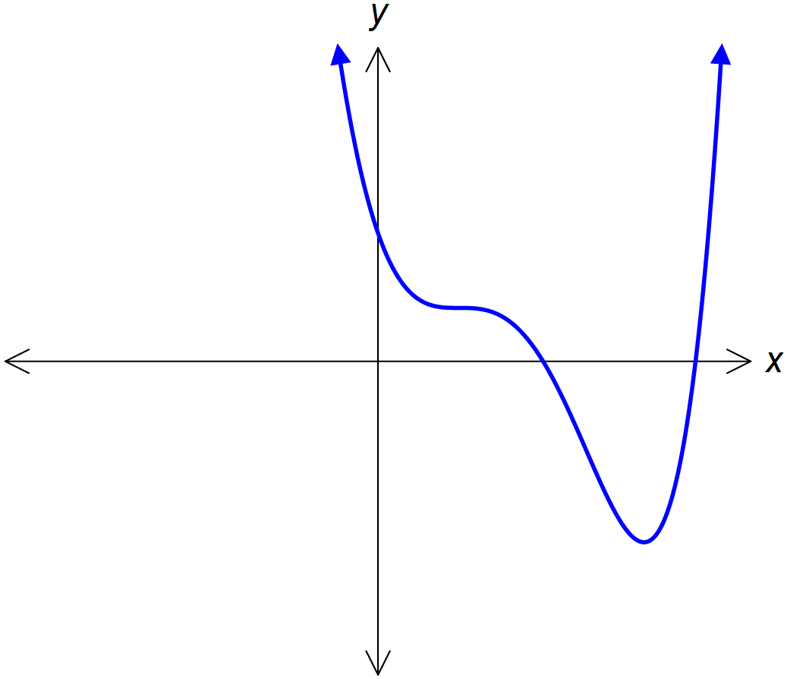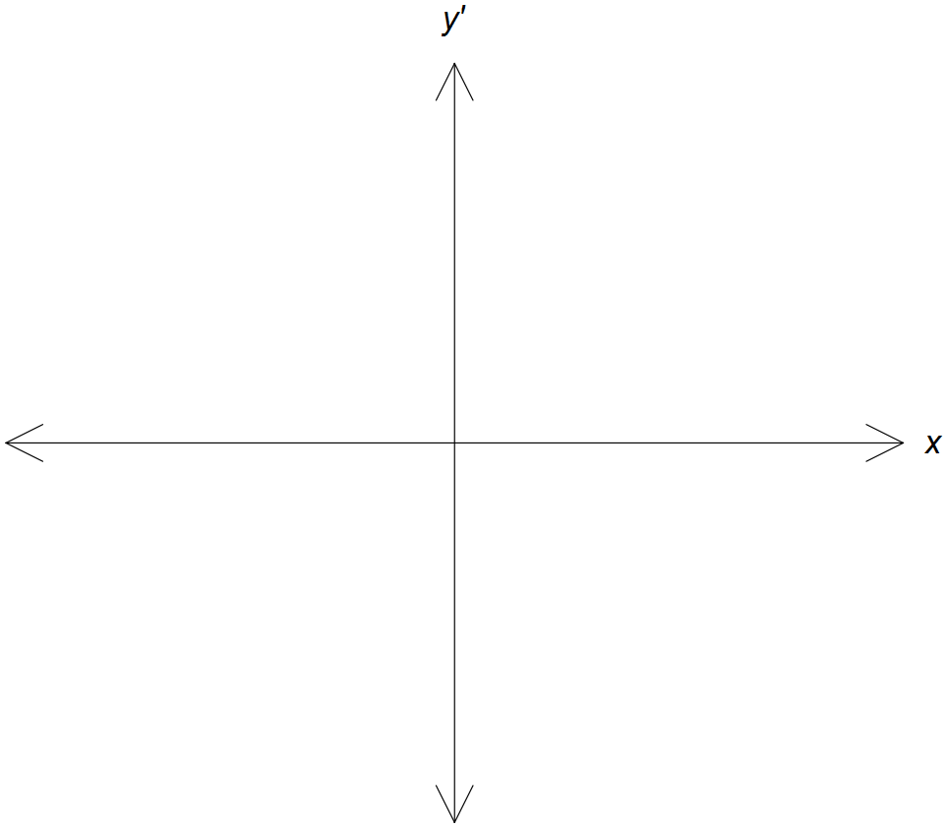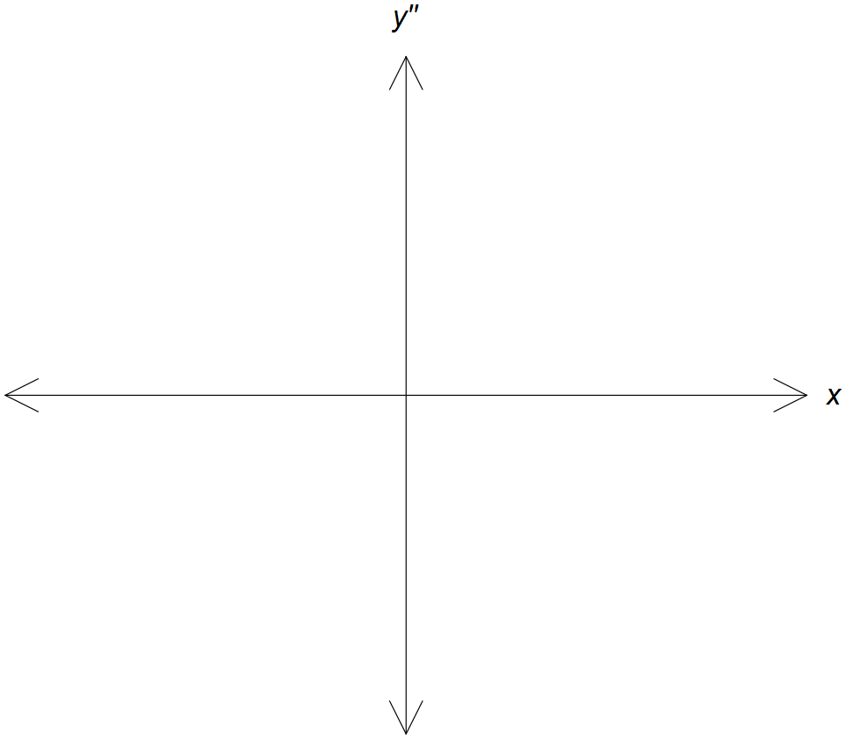

Question 15. [14 marks]

The diagram shows an arched church wooden window frame, to be made from 10m of timber.

*h*

2*r*

a) Find an expression for $h$ in terms of $r$.

[2]

b) Show that the area of the window is A = $10r- r^{2}\left(4+ \frac{π}{2}\right)$ [3]

Hence, or otherwise,

c) show that the **exact** value of r that maximises the area is $r= \frac{10}{8+π }$

[4]

d) Suppose the radius $(r)$ is increased by 10cm. Find the approximate change, using calculus methods, in the height of the window if the 10m of timber restriction still applies.

[3]

e) Interpret your answer in part (d). [1]

Question 16. [7 marks]

Consider a cylinder with a height that is three times its diameter.

a) Draw a diagram of the cylinder showing all measurements in terms of the radius $(r)$. [1]

b) Given that the volume of a cylinder is given by, $V_{Cylinder}=Area of Base×Height$, determine and expression for the volume of this cylinder in terms of radius $(r)$. [2]

c) Determine the percentage change in height when the volume of the cylinder increases by 4%.

[4]

Question 17 [7 marks]

1. If  and , use the chain rule to determine . [4]
2. For , determine the change in *y* when *x* changes from *x*=2 to *x* = 5.

[3]

Question 18. [8 marks]

An isosceles triangle has a perimeter of 80cm. If the two equal sides are labeled *x*, the third side *y*, and the perpendicular height *h*:

* 1. If it is known that *y* = 80 – 2*x*, show that  [3]



* 1. Using Calculus, determine the values of *x* and *y* if the area of the triangle is maximized. [5]

Question19. [6 marks]

* + - 1. The following shows the graph of the function. On the same set of axes draw a sketch of its derivative, 



* + - 1. Given that , prove that 

Question 20. [8 marks]

The Mass *M* (in grams) of a substance decaying after *t* years can be represented by  where *k* is a positive constant. There is 250 grams of the substance initially and after 2 years the mass of the substance has decayed to 190 grams.

* 1. If  for some constant *A*, show that . [2]
  2. Determine the value of *A* and the value of *k* to 4 decimal places. [2]
  3. How long will it take for the mass of the substance to reduce to 80 grams? [2]
  4. Determine the amount of time for the mass to reduce by half. [2]

Question 21. [6 marks]

Find the **exact** area of the region trapped between the curve, the *y*-axis and the line 

**END OF SECTION TWO**

**BLANK PAGE FOR EXTRA WORKING**

**LABEL THE QUESTION CLEARLY**

|  |  |  |
| --- | --- | --- |
| **Question** | **Possible Marks** | **Marks Achieved** |
| **8** | **7** |  |
| **9** | **4** |  |
| **10** | **7** |  |
| **11** | **7** |  |
| **12** | **4** |  |
| **13** | **3** |  |
| **14** | **12** |  |
| **15** | **14** |  |
| **16** | **7** |  |
| **17** | **7** |  |
| **18** | **9** |  |
| **19** | **4** |  |
| **20** | **9** |  |
| **21** | **6** |  |
| **TOTAL** | **100** |  |